SAMBA Server Configuration

Samba is the way a Linux computer

communicates with SMB and CIFS.

With Samba, you can make your Linux computer a part

of a Microsoft-based network.

Computers with various Microsoft operating systems

can communicate with each other using the Server

Message Block (SMB) protocol.

When a Microsoft operating system shares files or

printers on a TCP/IP network, it uses the Common

Internet File System (CIFS).

How SAMBA Server Works ?

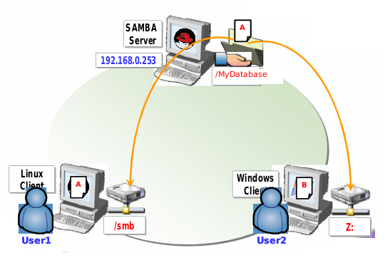

Requirements

Packages

samba-common-3.0.10-1.4E.i386.rpm

samba-3.0.10-1.4E.i386.rpm

samba-client-3.0.10-1.4E.i386.rpm

Port Numbers

137 NetBios Name Service

138 NetBios Datagram Service

139 NetBios Session Service

Configuration File

/etc/samba/smb.conf

Service

smb

Daemons

nmbd

smbd

Install the package by using one of the installation methods

[root@SambaServer Packages]# cd /media/Fedora\ 13\ i386\ DVD/Packages/

[root@SambaServer Packages]#rpm –ivh samba*

OR

Install the package by using yum installation method (Installation through Internet)

[root@SambaServer]# yum install samba*

Create directory to be shared

[root@SambaServer ]# mkdir /Mydatabase

Open configuration for editing

[root@SambaServer ]# vi /etc/samba/smb.conf

/etc/samba/smb.conf

To change the options
[myshare]
comment = This is My Samba Server
path = /Mydatabase
valid users = user1
browseable=yes
public = no
writable = yes
printable = no
create mask = 0765
save it by :wq

[root@SambaServer ]#useradd user1

[root@SambaServer ]#smbpasswd -a user1

[root@SambaServer ]#service smb restart

[root@SambaServer ]#chkconfig smb on

Note: - Samba password entries can be found at /etc/samba/smbpasswd

In Linux Client Side

Show the Shared Directory of Samba Server
showSamba Client 􀂱 Linux

[root@comp1 ~]#smbclient –L // 192.168.0.253/myshare –U user1

Mount Method

[root@comp1 ~]# mkdir /smb

[root@comp1 ~]# smbmount //192.168.0.253/Mydatabase
/smb 􀂱o username=user1
Password : ****

[root@comp1 ~]# cd /smb

FTP Method

[root@comp1 ~]# smbclient //192.168.0.253/myshare -U user1
Password : ****

smb/> ls

In Windows Client Side

Map Drive Samba Drive

1. Right click ‘My Network Places’

2. Select ‘Map Network Drive’

3. In the dialog box provide
Drive : Z:
Folder : \\192.168.0.253\myshare

. It opens authentication dialog box, where
username : user1
password : ****

Open Windows Explorer to find Z: drive mapped to Linux shared folder.

